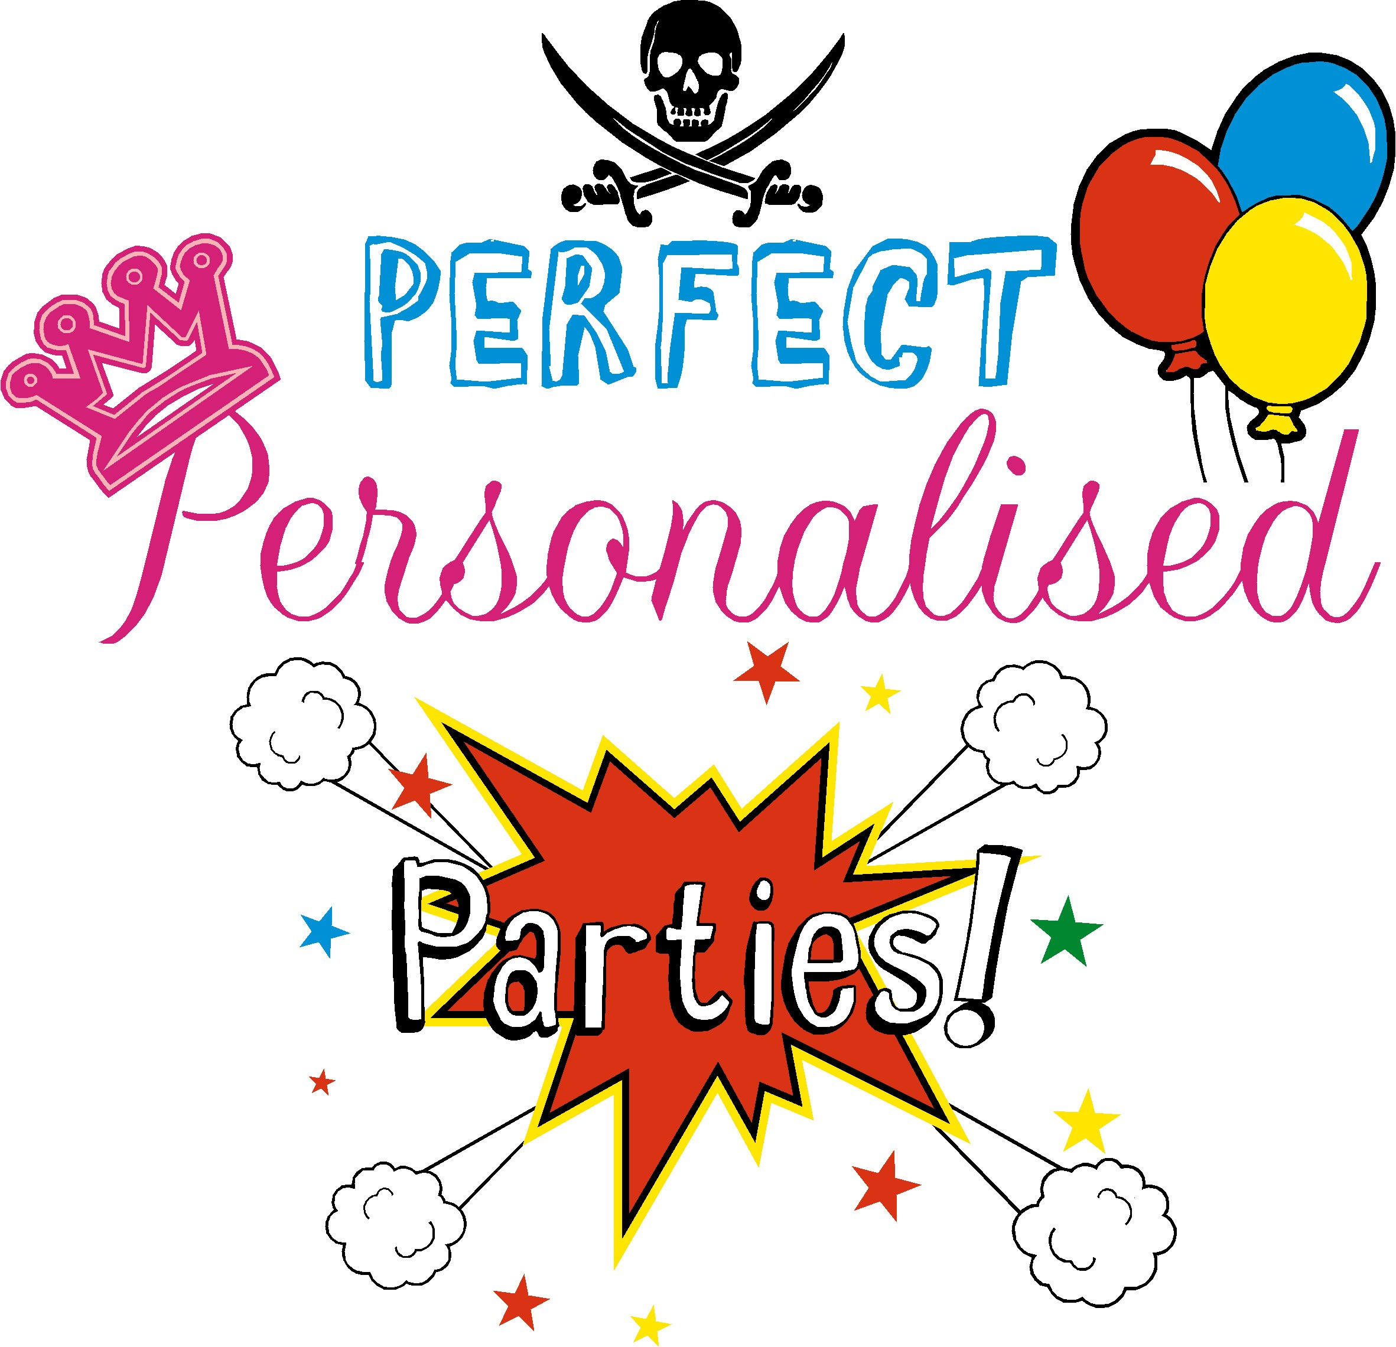

Bouncy Castle
Terms and Conditions of Hire

It is the responsibility of the person who is hiring this Bouncy Castle to ensure that all possible steps are taken to avoid injury or damage to the Inflatable. Please ensure that the following Safety instructions are followed:
- This unit has an age limit of 15 years of age. Please ensure that no-one over this age uses the equipment. Adults are not allowed to use the equipment.
- No food or drinks or chewing gum to be allowed on or near the Bouncy Castle which will avoid choking and mess (Please note that if the Inflatable is collected in a dirty condition then the person hiring it will incur a cleaning charge).
- All shoes, glasses, jewellery, badges MUST be removed before using the Bouncy Castle.
- No party poppers, coloured streamers or silly string to be used either on or near the Bouncy Castle.
- No smoking or barbeques near the Bouncy Castle.
- Climbing, hanging or sitting on walls is DANGEROUS and must not be allowed.
- A responsible ADULT must supervise the Bouncy castle at all times.
- Always ensure that the Bouncy Castle is not overcrowded and limit numbers according to the age and size of the Children using it. Try to avoid large and small Children from using it at the same time.
- Always ensure that Children are not pushing, colliding, fighting or behaving in a manner likely to injure or cause distress to others.
- No pets, toys or sharp instruments are allowed on or near the Bouncy Castle.
- If the Bouncy Castle is not being used for any part of the day, please switch the blower off at the mains.
- Do not allow anyone to bounce on the front safety step as a Child could easily bounce off the inflatable and get hurt. The step is there to assist users in getting on or off.
- Ensure that no-one with a history of back or neck problems is allowed on the Bouncy Castle or any Child that are feeling unwell.
- Do not allow anyone to be on the Bouncy castle during inflation or deflation as this is DANGEROUS.
- Please ensure that Children are not attempting somersaults and are clothed appropriately and that nothing can fall out of their pockets.
- The Bouncy Castle should not be used if it becomes wet on the jumping area.
- If a rain cover is not fitted, in the event of rain, the unit should not be used. In the event of heavy rain and high wind, it is strongly recommended that the Bouncy Castle be switched off. Any wetness, including bubbling (which is normal) can be dried with a towel.
- In the event that the blower stops working, please ensure all users get off the inflatable immediately. If the blower stops working check the fuses and make sure the blower tube or deflation tube has not come undone or something has not blown onto and is obstructing the blower.
- In the event that it overheats, or loses power, switch the blower off at the mains, then switch it back on again 1 or 2 minutes later. If it does not restart then contact us straight away.

DISCLAIMER
Please note that all persons using this Bouncy Castles do so at their own risk.
The person/s or organisation hiring this Inflatable equipment will be responsible/liable for any damage or injury occurring from or as a result of misuse/ reckless use. These guidelines are for the safety of all people using this equipment and it is the sole responsibility of the hirer to ensure that they are fully adhered to at all times. Our Company cannot accept any responsibility for any injury caused to anyone using the equipment. By ticking the box on the website, I agree and fully understand and accept the conditions as above. I am aware that whilst in my care I am fully responsible for the Inflatable and will pay for any loss or damage that may occur, this will include the Inflatable being returned in an unacceptable condition i.e. if it is in a dirty or muddy condition, I will be expected to pay an additional cleaning charge of a minimum fee of £50. The £20 booking fee is non-refundable due to any circumstances including weather, customer cancelations or pandemics. Chloes Castles is a trading name of Perfect Personalised Parties UK Ltd.

By ticking the terms and conditions box on the website you agree to all of the above terms and is a legally binding contract. If you don’t agree to any of the terms, please don’t tick the box and contact us immediately to discuss.

